NAME : NDAYISHIMIYE PATRICK

REGISTRATION NUMBER: 21RP 00852

PROJECT NAME: DARK SENSOR AND LIGHT ON THE LAMP.

INTRODUCTION

IN OUR REALLY LIFE the dark is the dangerous thing that’s can course so many accident

In my project I would like to solve this problem, I used (LDR) AS DARK SENSOR AND THEN GIVE THE LIGHT AUTOMATICAL BY USING LAMP.

SENSOR

IS THE MACHINE OR DEVICE THAT DETECT THE PHYISICAL QUANTITY AND THEN GIVE THE ELECTRICAL SIGNAL.

THE DARK SENSOR ALSO MAY USE LDR AS THE MAIN COMPONENT TO SENSE THAT DARKNESS AND GIVE THE SIGNAL.

APPLICATION

1.Home

2.HOSPITALY

3.STREET LIHTING

4.SCHOOLS

5.ETC

THE MAIN PURPOSE OF MY PROJECT IS TO FIGHT AGAINSTY DARKNESS DURING THE NIGHT TIME, AND PROVIDE THE LIGHT AUTOMATICAL.

THE COMPONENT THAT USED

1.ARDUINO UNO

2.BREAD BOARD

3.JUMPER WIRE

4.RESISTOR

5.LDR AND LAMPS

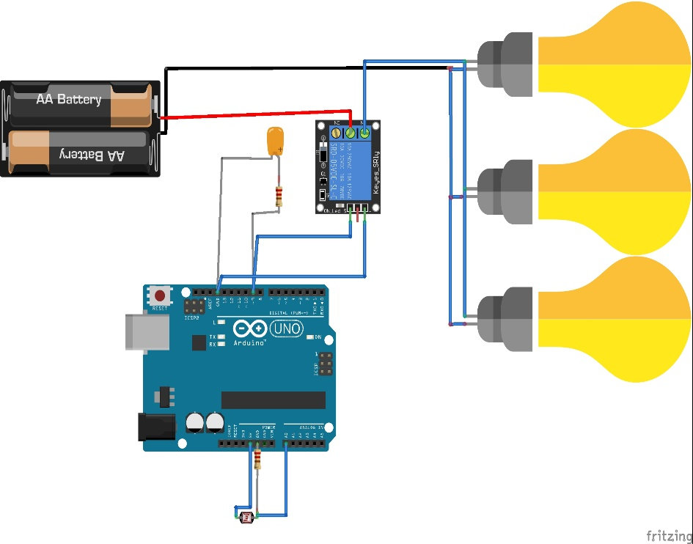

ABOVE THERE IS CIRCUIT DIAGRAM OF MY PROJECT.

BELOW ALSO THE IS THE CODE I USED TO RUN MY PROJECT

// Define pins

int relay = 9; // relay pin

int photoPin = A0; // Photoresistor pin

// Define threshold value

void setup() {

// Initialize serial communication

Serial.begin(9600);

// Set LED pin as output

pinMode(relay, OUTPUT);

}

void loop() {

// Read analog value from photoresistor

int photoValue = analogRead(photoPin);

// Print value to serial monitor

Serial.println(photoValue);

// If photoresistor value is below threshold, turn LED on

if (photoValue <=100) {

digitalWrite(relay, HIGH);

} else {

digitalWrite(relay, LOW);

}

// Delay to reduce sensor noise

delay(100);

}

THE LINK WHICH CAN SHOW HOW THE PROJECT IS DESCRIBED

https://youtu.be/dPW-SFKlUUQ